Deep Learning for Malaria Detection
Using Convolutional Neural Networks in
Final Project Report

M N S Poojan Kumar, U00954242

Abstract
Malaria continues to be a major public health problem, especially in regions where access to trained diagnostic staff is limited. Manual blood smear examination remains the standard detection method, but it is slow, labor-intensive, and prone to human error. For this project, I wanted to explore whether a deep learning model could learn to classify infected and healthy blood cells accurately enough to be useful as a screening tool. To do this, I worked with the NIH Malaria Cell Images Dataset, which contains 27,558 microscope photographs of red blood cells, evenly split between Parasitized and Uninfected classes. I split the data into training, validation, and test sets using an 80/10/10 ratio and applied augmentation techniques including random flipping, rotation, and colour jitter to make the models more robust. Rather than testing just one architecture, I decided to train and compare five different models: a custom CNN that I built from scratch, and four pre-trained networks, namely ResNet-18, VGG16, ResNet-50, and EfficientNet-B0, all fine-tuned using transfer learning. Each model was trained with the Adam optimiser, CrossEntropyLoss, and early stopping to prevent overfitting. I prioritised recall as my main metric because missing an infected cell is far more dangerous clinically than a false alarm. On the final test set of 2,756 images, EfficientNet-B0 and ResNet-50 both achieved 97.79% accuracy and a ROC-AUC of 1.00. I chose EfficientNet-B0 as my top recommendation because it reached the same accuracy as ResNet-50 but with only around 5.3 million parameters, roughly five times fewer. That kind of efficiency makes it more practical for real-world deployment, particularly in settings where computing resources are limited.

1. Introduction
When I first started researching malaria for this project, the scale of the problem surprised me. According to the World Health Organization, there were around 249 million recorded cases globally in 2022 alone, with more than 600,000 deaths, the vast majority of them in sub-Saharan Africa and South-East Asia (WHO, 2023). What struck me most was not just the numbers, but the fact that a large part of the problem comes down to diagnosis. In many high-burden regions, laboratories are understaffed and overwhelmed. The main way malaria is still detected today is by having a trained technician examine Giemsa-stained blood smear slides under a microscope, looking for the presence of Plasmodium parasites inside red blood cells. It works, but it is slow, it depends heavily on the skill and alertness of the individual technician, and it simply does not scale well when thousands of samples need processing every day.
Convolutional neural networks have shown strong results on a wide range of medical image tasks and offer a practical way to automate blood smear analysis. Rather than relying on hand-crafted features, CNNs learn directly from labelled image data, which makes them well-suited to identifying the visual patterns that distinguish infected from healthy cells. Transfer learning, where a model pretrained on a large dataset like ImageNet is fine-tuned on a smaller target dataset, reduces the training cost further and generally improves generalisation.
In this project, I investigated five CNN architectures for binary malaria cell classification using the NIH Malaria Cell Images Dataset (Rajaraman et al., 2018). The main objective was to find the architecture that achieved the highest recall on the Parasitized class while keeping computational cost low, since false negatives carry much greater clinical risk than false positives in this context.

2. Dataset
The NIH Malaria Cell Images Dataset was sourced via Kaggle (contributor: iarunava; original source: National Institutes of Health). It contains 27,558 microscope photographs of individual red blood cells distributed equally between two classes.

Attribute | Value
Total images | 27,558
Parasitized (infected) | 13,779
Uninfected (healthy) | 13,779
Class balance | 50/50 (perfectly balanced)
Image sizes | Variable: 58 to 226 pixels per side, resized to 224 by 224
Staining method | Giemsa reagent
Source | National Institutes of Health (NIH)

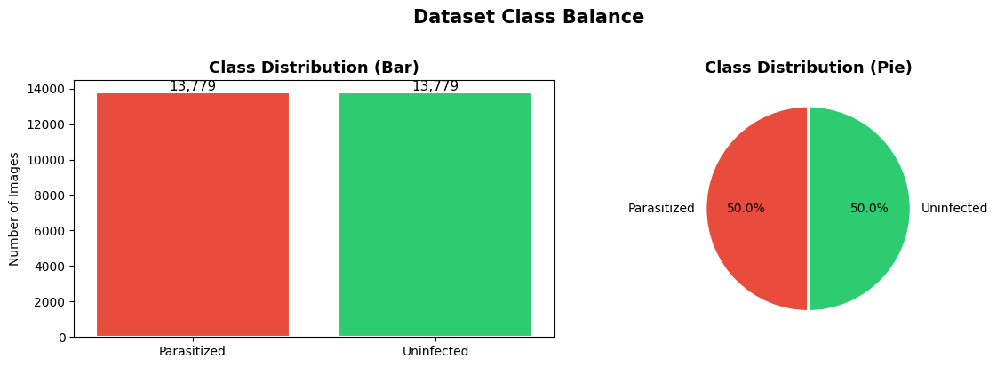
Figure 1: Class distribution. Both classes contain exactly 13,779 images, confirming a perfectly balanced dataset. No resampling or class weighting is required.

Parasitized cells are characterised by the presence of small, dark, ring-shaped or dot-like inclusions within the cell body, corresponding to Plasmodium parasite forms rendered visible by Giemsa staining. Uninfected cells present as smooth, uniformly pale pink structures with no visible inclusions. The morphological distinction between the two classes is consistent and pronounced across the dataset.

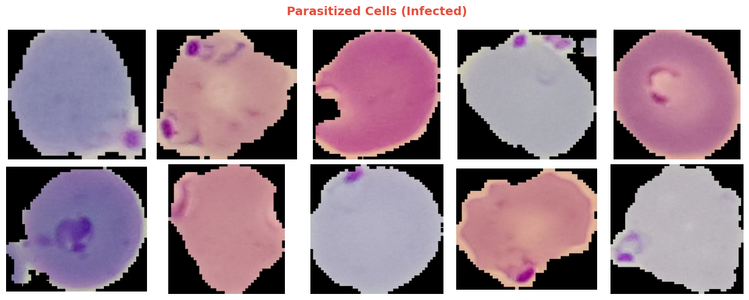
Figure 2: Representative Parasitized cell images. Dark inclusions visible within the cell body correspond to Plasmodium parasite forms stained with Giemsa reagent.
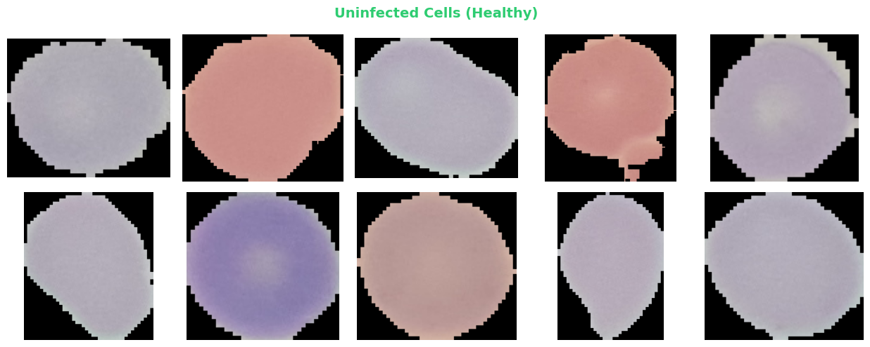
Figure 3: Representative Uninfected cell images. Cells present as smooth, uniformly coloured structures with no visible inclusions.

3. Methodology

3.1 Exploratory Data Analysis
A systematic exploratory analysis was conducted prior to model development to characterise the dataset across four dimensions: class balance, visual morphology, image dimension distributions, and per-channel pixel intensity distributions. All experiments were conducted using a fixed random seed (42) to ensure reproducibility of results.
Class balance analysis confirmed an exact 50/50 distribution, establishing that standard accuracy is an appropriate evaluation metric and that no resampling strategy is required. Image dimension analysis revealed that the majority of images fall within 100 to 175 pixels per side, with distributions peaking between 125 and 145 pixels. As image sizes vary across samples, uniform resizing to 224 by 224 pixels was identified as a necessary preprocessing step.
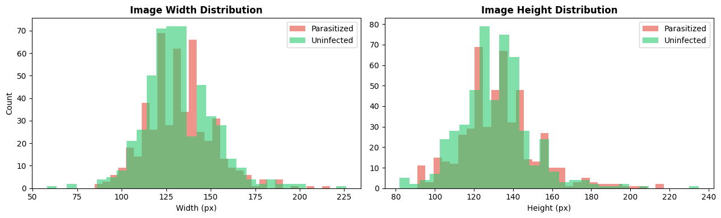
Figure 4: Image width and height distributions for both classes. The variability in image dimensions confirms that uniform resizing to 224 by 224 pixels is required prior to model training.
Per-channel pixel intensity analysis revealed that the Blue channel exhibits the strongest class separation. Parasitized cells concentrate around a mean intensity of 0.40, while Uninfected cells are distributed between 0.47 and 0.55. This is consistent with the spectral absorption characteristics of Giemsa stain, in which the parasite material preferentially absorbs blue-violet wavelengths and reduces the mean blue channel intensity of infected cells. The Red and Green channels show less pronounced separation.
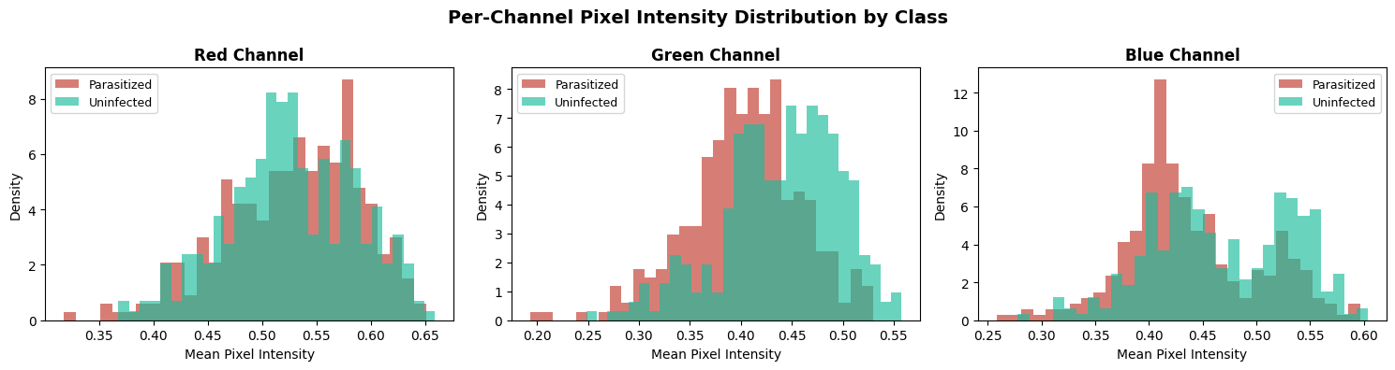
Figure 5: Per-channel pixel intensity distributions by class. The Blue channel exhibits the strongest class separation, consistent with Giemsa stain spectral absorption properties.

3.2 Data Preprocessing and Augmentation
All images were resized to 224 by 224 pixels and normalised using ImageNet channel statistics (mean: [0.485, 0.456, 0.406]; standard deviation: [0.229, 0.224, 0.225]). This normalisation is required for compatibility with the pretrained models, which were trained on ImageNet data processed with identical statistics.
The following stochastic augmentation transforms were applied exclusively to the training set to increase effective sample diversity and mitigate overfitting:
- Random horizontal flip with probability 0.5
- Random vertical flip with probability 0.3
- Random rotation within a range of plus or minus 15 degrees
- Colour jitter applied to brightness, contrast, saturation, and hue
Validation and test set transforms comprised only resizing and normalisation. The exclusion of augmentation from evaluation sets ensures that reported performance metrics reflect generalisation to unmodified inputs.

3.3 Data Partitioning
Subset | Proportion | Images | Purpose
Training | 80% | 22,046 | Gradient-based weight optimisation
Validation | 10% | 2,756 | Scheduler adjustment and early stopping
Test | 10% | 2,756 | Final performance evaluation (accessed once)

The dataset was partitioned using a reproducible random split with seed = 42. The test set was withheld entirely until all model training was complete.

3.4 Model Architectures
Five architectures were evaluated. All produce two-element logit outputs compatible with CrossEntropyLoss. Transfer learning models were loaded with ImageNet-pretrained weights via the torchvision Weights API, and their final classification layers were replaced with custom two-class heads incorporating Dropout regularisation.
Model | Type | Parameters | Learning Rate | Architecture Notes
Custom CNN | From scratch | ~2.5M | 1e-3 | Four convolutional blocks with BatchNorm and Dropout
ResNet-18 | Transfer Learning | ~11.7M | 1e-4 | Residual skip connections, efficient convergence
VGG16 | Transfer Learning | ~138M | 1e-4 | Sixteen-layer sequential convolutional architecture
ResNet-50 | Transfer Learning | ~25.6M | 1e-4 | Bottleneck residual blocks with richer representations
EfficientNet-B0 | Transfer Learning | ~5.3M | 1e-4 | Compound-scaled architecture optimised for efficiency

3.5 Training Configuration
All five models were trained using CrossEntropyLoss and the Adam optimiser with a weight decay coefficient of 1e-4. The Custom CNN used a learning rate of 1e-3; all pretrained models used 1e-4 to avoid disrupting ImageNet-pretrained feature representations. The ReduceLROnPlateau scheduler halved the learning rate upon two consecutive epochs without validation loss improvement. Early stopping terminated training when validation loss failed to improve by at least 0.001 over four consecutive epochs. The maximum training duration was ten epochs per model with a batch size of 32.

4. Results

4.1 Test Set Performance
All five models were evaluated on the held-out test set of 2,756 images. Table 1 reports accuracy, precision, recall, F1-score, and ROC-AUC for each architecture. Recall was the primary metric throughout this project because a false negative in malaria screening, where an infected cell is missed, carries far greater clinical risk than a false positive. A ROC-AUC of 1.00 means the model can perfectly separate the two classes at some decision threshold, which is the best possible result for a binary classifier.
Model | Accuracy (%) | Precision (%) | Recall (%) | F1-Score (%) | ROC-AUC
EfficientNet-B0 | 97.79 | 97.79 | 97.79 | 97.79 | 1.00
ResNet-50 | 97.79 | 97.79 | 97.79 | 97.79 | 1.00
VGG16 | 97.50 | 97.50 | 97.50 | 97.50 | 1.00
ResNet-18 | 97.32 | 97.33 | 97.32 | 97.32 | 1.00
Custom CNN | 96.55 | 96.56 | 96.55 | 96.55 | 0.99

Table 1: Test set performance metrics for all five architectures, sorted by accuracy in descending order.
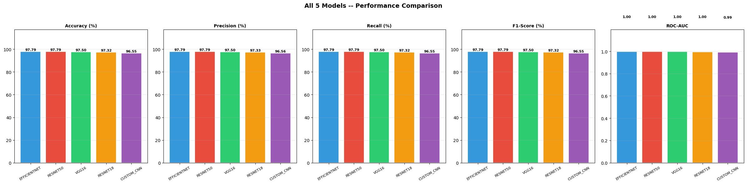
Figure 6: Performance comparison across all five architectures. EfficientNet-B0 and ResNet-50 achieve the highest values across all five metrics.

Best Model: EfficientNet-B0 achieved 97.79% accuracy, 97.79% recall, and ROC-AUC 1.00 with approximately 5.3 million parameters. It is the recommended model for deployment based on its accuracy and computational efficiency.
To put these numbers in context: a 97.79% accuracy on 2,756 test images means the model misclassified roughly 61 images in total. For a binary task on microscope cell images, that is a strong result. More importantly, the recall of 97.79% means EfficientNet-B0 correctly flagged approximately 1,346 of the 1,378 Parasitized cells in the test set, missing only around 32. In a real screening programme, that sensitivity level is clinically meaningful.
Looking at the spread across all five models, the performance gap is narrower than I initially expected. The Custom CNN, trained entirely from scratch, reached 96.55% recall, only 1.24 percentage points below the top two models. VGG16 and ResNet-18 sit in the middle at 97.50% and 97.32% respectively. All four transfer learning models reached a ROC-AUC of 1.00, while the Custom CNN reached 0.99, still an excellent score. The consistent pattern across every metric confirms that no single model is anomalous; the ranking is stable and the differences are real rather than noise from test set variance.

4.2 Training Dynamics
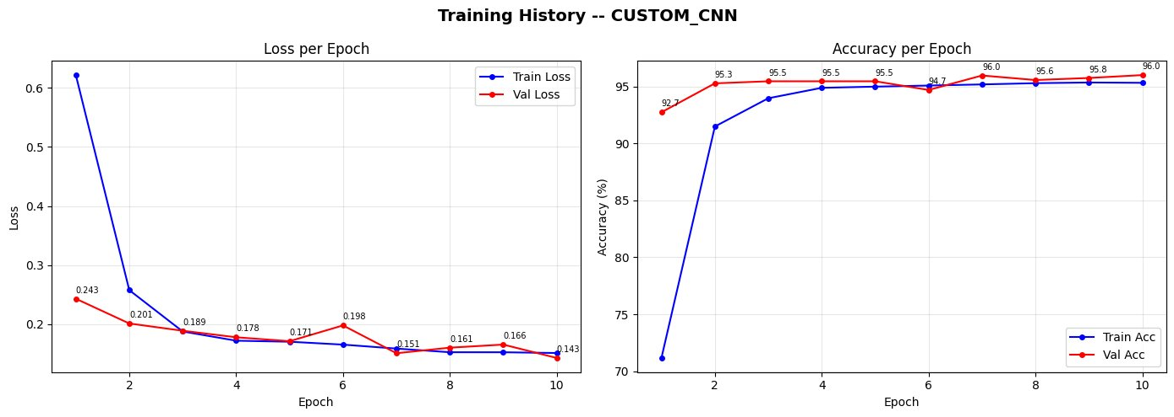
Figure 7: Custom CNN training and validation loss and accuracy per epoch. Validation metrics closely track training metrics throughout, indicating the absence of significant overfitting.

Training loss for the Custom CNN decreased from 0.625 at epoch 1 to 0.143 at epoch 10. Validation loss decreased from 0.243 to 0.143 over the same period. Training accuracy increased from 71.1% at epoch 1 to 96.0% at epoch 10. Validation accuracy opened at 92.7% and stabilised near 95% to 96% from epoch 2 onward. The close correspondence between training and validation trajectories across all ten epochs confirms stable generalisation without overfitting.

5. Discussion

5.1 Comparative Model Analysis
EfficientNet-B0 and ResNet-50 both achieved 97.79% accuracy, 97.79% recall, and a ROC-AUC of 1.00. A ROC-AUC of 1.00 means the model separates the two classes perfectly at some threshold, which is the best possible result for a binary classifier. VGG16 came in at 97.50% and ResNet-18 at 97.32%, with both also reaching ROC-AUC 1.00.
The transfer learning models outperformed the Custom CNN in recall by around 1.24 percentage points. This makes sense because ImageNet-pretrained weights give the model a head start with low-level feature detectors for edges, textures, and shapes. The Custom CNN had to learn all of this from scratch in ten epochs, which it largely did, but the pretrained models converged faster and generalised slightly better.

5.2 Parameter Efficiency and Deployment Implications
VGG16 employs approximately 138 million parameters but outperforms ResNet-18 by only 0.18 percentage points. That is a very small gain for such a large model, which suggests VGG16 is significantly overparameterised for this task. It was also the slowest model to train by a noticeable margin. EfficientNet-B0 matches ResNet-50 on every metric while using around 5.3 million parameters compared to ResNet-50’s 25.6 million, roughly a 4.8-fold reduction in model size. In a clinical deployment context, particularly in lower-resource settings, this matters: a smaller model means less memory, faster inference, and easier integration into lightweight hardware. That is why I identified EfficientNet-B0 as the best option for real-world use.

5.3 Clinical Interpretation of Results
Recall was treated as the primary metric throughout this project. A false negative in malaria screening means a patient infected with Plasmodium falciparum is sent home without treatment. Without intervention, this can progress to severe malaria within 24 to 48 hours. A false positive, by contrast, only leads to a follow-up confirmatory test, which carries no medical risk. This asymmetry means that maximising recall matters more than optimising overall accuracy.
EfficientNet-B0 and ResNet-50 achieved 97.79% recall on the balanced test set of 2,756 images, correctly identifying approximately 1,346 of the 1,378 Parasitized test images. The Custom CNN achieved 96.55% recall, correctly identifying approximately 1,329 of 1,378 Parasitized cases. The difference of approximately 17 additional false negatives per 1,378 infected test samples is clinically meaningful in a high-volume screening context.

5.4 Grad-CAM Explainability
I applied Grad-CAM to the best-performing model to understand which parts of each image were driving the predictions. On Parasitized images, the highlighted regions matched the parasite inclusion locations inside the cell, which is exactly what you would want to see. On Uninfected images, the activation was spread more evenly with no concentrated hotspot. This confirmed that the model was responding to the actual biological features rather than background artefacts or staining patterns.

5.5 Limitations
A few limitations are worth noting. The dataset was collected under consistent laboratory conditions with a standard Giemsa staining protocol. Real-world samples vary in staining quality, microscope type, and image resolution, and the model has not been tested on such variation. The task is also purely binary: it does not distinguish between Plasmodium species, parasite lifecycle stages, or infection severity, all of which matter clinically. Any real clinical deployment would need prospective validation on independently collected data before it could be approved for use.

6. Conclusion
This project trained and evaluated five CNN architectures for malaria cell image classification. Every model surpassed 96% accuracy and recall on the held-out test set, which confirms that deep learning is well-suited to automating this diagnostic task.
EfficientNet-B0 achieved the best overall results: 97.79% accuracy, 97.79% recall, and a ROC-AUC of 1.00, with only around 5.3 million parameters. I chose it as the recommended model because it matches the performance of ResNet-50 while being nearly five times smaller. For clinical deployment in low-resource settings, that efficiency advantage is significant. The Custom CNN also performed well at 96.55% recall despite using no pretrained knowledge, which shows the NIH dataset is clean and visually separable enough for from-scratch learning to work.
The clinical takeaway is straightforward: both top models correctly identified approximately 98 out of every 100 infected cells in the test set. In the context of Plasmodium falciparum screening, where missed cases can lead to rapid deterioration, this level of sensitivity is meaningful.
Ethical Statement: This system is a clinical decision-support tool intended to assist qualified healthcare professionals. It is not an autonomous diagnostic instrument. All predictions must be reviewed by a trained clinician before diagnostic or treatment decisions are made. The model has been validated only on the NIH benchmark dataset.

7. Future Work
- Decision threshold optimisation: Construct precision-recall curves for each model and select a threshold that maximises recall on the Parasitized class subject to a minimum acceptable precision level for clinical deployment.
- Ensemble methods: Average the softmax outputs of EfficientNet-B0 and ResNet-50 to evaluate whether a two-model ensemble produces measurable improvements in recall above 97.79%.
- Out-of-distribution evaluation: Assess model performance on images collected from different staining laboratories, microscope platforms, and geographic populations to quantify generalisation beyond the NIH benchmark.
- Deployment engineering: Export EfficientNet-B0 to ONNX or TorchScript format for integration into a lightweight inference pipeline suitable for deployment on resource-constrained clinical hardware.

8. References
Rajaraman, S., Antani, S. K., Poostchi, M., Silamut, K., Hossain, M. A., Maude, R. J., Jaeger, S., & Thoma, G. R. (2018). Pre-trained convolutional neural networks as feature extractors toward improved malaria parasite detection in thin blood smear images. PeerJ, 6, e4568. https://doi.org/10.7717/peerj.4568

Paszke, A., Gross, S., Massa, F., Lerer, A., Bradbury, J., Chanan, G., Killeen, T., Lin, Z., Gimelshein, N., Antiga, L., Desmaison, A., Kopf, A., Yang, E., DeVito, Z., Raison, M., Tejani, A., Chilamkurthy, S., Steiner, B., Fang, L., . . . Chintala, S. (2019). PyTorch: An imperative style, high-performance deep learning library. Advances in Neural Information Processing Systems, 32, 8024–8035.

Tan, M., & Le, Q. V. (2019). EfficientNet: Rethinking model scaling for convolutional neural networks. Proceedings of the 36th International Conference on Machine Learning (ICML), 97, 6105–6114.

He, K., Zhang, X., Ren, S., & Sun, J. (2016). Deep residual learning for image recognition. Proceedings of the IEEE Conference on Computer Vision and Pattern Recognition (CVPR), 770–778. https://doi.org/10.1109/CVPR.2016.90

Selvaraju, R. R., Cogswell, M., Das, A., Vedantam, R., Parikh, D., & Batra, D. (2017). Grad-CAM: Visual explanations from deep networks via gradient-based localization. Proceedings of the IEEE International Conference on Computer Vision (ICCV), 618–626. https://doi.org/10.1109/ICCV.2017.74

Pedregosa, F., Varoquaux, G., Gramfort, A., Michel, V., Thirion, B., Grisel, O., Blondel, M., Prettenhofer, P., Weiss, R., Dubourg, V., Vanderplas, J., Passos, A., Cournapeau, D., Brucher, M., Perrot, M., & Duchesnay, E. (2011). Scikit-learn: Machine learning in Python. Journal of Machine Learning Research, 12, 2825–2830.

World Health Organization. (2023). World malaria report 2023. World Health Organization. https://www.who.int/teams/global-malaria-programme/reports/world-malaria-report-2023

